AI ASSISTED CODING
ASSIGNMENT - 13.1&13.5
NAME: P.SAI SHANKAR
HL-NO: 2303A52500 BATCH: 50
Lab 11.3 and 11.5:
Task-1:
class Node:
def __init__(self, name, phone):
self.name = name
self.phone = phone
self.next = None
class ContactManagerLinkedList:
def __init__(self):
self.head = None
def add_contact(self, name, phone):
new_node = Node(name, phone)
new_node.next = self.head
self.head = new_node
def search_contact(self, name):
current = self.head
while current:
if current.name.lower() == name.lower():
return {"name": current.name, "phone": current.phone}
current = current.next
return None
def delete_contact(self, name):
current = self.head
prev = None
while current:
if current.name.lower() == name.lower():
if prev:
prev.next = current.next
else:
self.head = current.next
return {"name": current.name, "phone": current.phone}
prev = current
current = current.next
return None

if __name__ == "__main__":
cm = ContactManagerLinkedList()
cm.add_contact("Alice", "1234567890")
cm.add_contact("Bob", "0987654321")

print("Search Alice:", cm.search_contact("Alice"))
print("Delete Bob:", cm.delete_contact("Bob"))
print("Search Bob after deletion:", cm.search_contact("Bob"))

Output -
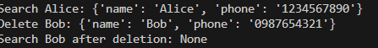

Task-2 :
from collections import deque
import heapq

# Task 1: Book Request representation
class BookRequest:
def __init__(self, requester_name, requester_type, book_title):
self.requester_name = requester_name
self.requester_type = requester_type.lower() # 'faculty' or 'student'
self.book_title = book_title
def __str__(self):
return f"[{self.requester_type.capitalize()}] {self.requester_name} - '{self.book_title}'"
# Task 2: Standard FIFO Queue
class StandardQueue:
def __init__(self):
self.queue = deque()
def enqueue(self, request):
print(f"Enqueued to FIFO: {request}")
self.queue.append(request)
def dequeue(self):
if not self.is_empty():
removed = self.queue.popleft()
print(f"Dequeued from FIFO: {removed}")
return removed
print("FIFO Queue is empty.")
return None
def is_empty(self):
return len(self.queue) == 0
# Task 3: Priority Queue (Faculty prioritized over Student)
class PriorityQueue:
def __init__(self):
self.heap = []
self._count = 0 # To maintain stability for same priority (FIFO within priority)
def enqueue(self, request):
# Faculty has priority 0, Student has priority 1
priority = 0 if request.requester_type == "faculty" else 1
# (priority, order_added, request)
print(f"Enqueued to Priority Queue: {request}")
heapq.heappush(self.heap, (priority, self._count, request))
self._count += 1
def dequeue(self):
if not self.is_empty():
priority, order, request = heapq.heappop(self.heap)
print(f"Dequeued from Priority Queue: {request}")
return request
print("Priority Queue is empty.")
return None
def is_empty(self):
return len(self.heap) == 0
# Task 4: Test the system
if __name__ == "__main__":
requests = [
BookRequest("Alice", "student", "Introduction to Algorithms"),
BookRequest("Dr. Smith", "faculty", "Advanced Quantum Physics"),
BookRequest("Bob", "student", "The Great Gatsby"),
BookRequest("Prof. Miller", "faculty", "Data Structures"),
]
print("--- FIFO Queue Processing ---")
fifo = StandardQueue()
for req in requests:
fifo.enqueue(req)
while not fifo.is_empty():
fifo.dequeue()
print("\n--- Priority Queue Processing (Faculty First) ---")
pq = PriorityQueue()
for req in requests:
pq.enqueue(req)
while not pq.is_empty():
pq.dequeue()

Output -
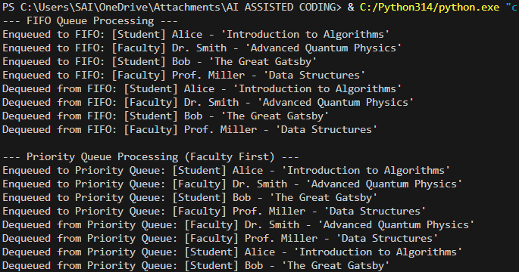

Task-3:
# Stack Implementation for Help Desk Tickets

class Stack:
def __init__(self, max_size=10):
self.stack = []
self.max_size = max_size
# push operation
def push(self, ticket):
if self.is_full():
print("Stack is full. Cannot add ticket.")
else:
self.stack.append(ticket)
print(f"Ticket '{ticket}' added.")
# pop operation
def pop(self):
if self.is_empty():
print("No tickets to resolve.")
else:
ticket = self.stack.pop()
print(f"Ticket '{ticket}' resolved.")
# peek operation
def peek(self):
if self.is_empty():
print("No tickets in stack.")
else:
print("Next ticket to resolve:", self.stack[-1])
# check if stack is empty
def is_empty(self):
return len(self.stack) == 0
# check if stack is full
def is_full(self):
return len(self.stack) == self.max_size
# Simulation
helpdesk = Stack()
helpdesk.push("WiFi not working")
helpdesk.push("Email login issue")
helpdesk.push("Projector not connecting")
helpdesk.push("System slow")
helpdesk.push("Printer not responding")
print("\nCurrent Ticket:")
helpdesk.peek()
print("\nResolving Tickets:")
helpdesk.pop()
helpdesk.pop()
helpdesk.pop()
helpdesk.pop()
helpdesk.pop()

Output-
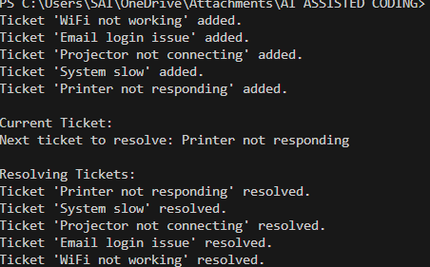

Task-4:
# Hash Table Implementation using Chaining

class HashTable:
def __init__(self, size=10):
self.size = size
self.table = [[] for _ in range(size)]
# Hash function
def hash_function(self, key):
return hash(key) % self.size
# Insert operation
def insert(self, key, value):
index = self.hash_function(key)
self.table[index].append((key, value))
print(f"Inserted: {key} -> {value}")
# Search operation
def search(self, key):
index = self.hash_function(key)
for k, v in self.table[index]:
if k == key:
return v
return "Key not found"
# Delete operation
def delete(self, key):
index = self.hash_function(key)
for i, (k, v) in enumerate(self.table[index]):
if k == key:
del self.table[index][i]
print(f"Deleted key: {key}")
return
print("Key not found")
# Testing
ht = HashTable()
ht.insert("ID101", "Sai")
ht.insert("ID102", "Rahul")
ht.insert("ID103", "Anita")
print("Search ID102:", ht.search("ID102"))
ht.delete("ID102")
print("Search ID102:", ht.search("ID102"))

Output-
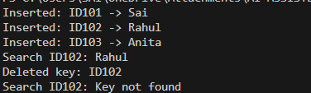

Task-5:

from collections import deque
class CafeteriaQueue:
def __init__(self):
self.queue = deque()
# place order
def place_order(self, order):
self.queue.append(order)
print(f"Order placed: {order}")
# serve order
def serve_order(self):
if len(self.queue) == 0:
print("No orders to serve.")
else:
order = self.queue.popleft()
print(f"Serving order: {order}")
# display orders
def display_orders(self):
print("Current Orders:", list(self.queue))
# Simulation
cafeteria = CafeteriaQueue()
cafeteria.place_order("Burger")
cafeteria.place_order("Pizza")
cafeteria.place_order("Sandwich")
cafeteria.place_order("Coffee")
cafeteria.display_orders()
cafeteria.serve_order()
cafeteria.serve_order()
cafeteria.display_orders()

Output-
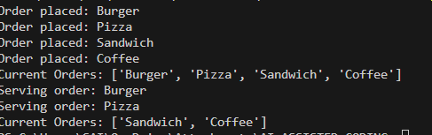

11.5
Task-1:
class Stack:
"""
Stack implementation using Python list.
Follows LIFO (Last In First Out).
"""

def __init__(self):
self.items = []
def push(self, item):
"""Insert element into stack."""
self.items.append(item)
def pop(self):
"""Remove top element."""
if not self.is_empty():
return self.items.pop()
return "Stack is empty"
def peek(self):
"""View top element."""
if not self.is_empty():
return self.items[-1]
return "Stack is empty"
def is_empty(self):
"""Check if stack is empty."""
return len(self.items) == 0
# Example Usage
s = Stack()
s.push(10)
s.push(20)
s.push(30)
print("Top:", s.peek())
print("Removed:", s.pop())
print("Stack Empty:", s.is_empty())

Output-
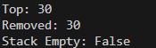

Task-2:
class Queue:
"""
Queue implementation using list.
Follows FIFO (First In First Out).
"""

def __init__(self):
self.items = []
def enqueue(self, item):
"""Add element to queue."""
self.items.append(item)
def dequeue(self):
"""Remove first element."""
if len(self.items) > 0:
return self.items.pop(0)
return "Queue is empty"
def peek(self):
"""View first element."""
if len(self.items) > 0:
return self.items[0]
return "Queue is empty"
def size(self):
"""Return queue size."""
return len(self.items)
# Example
q = Queue()
q.enqueue("A")
q.enqueue("B")
q.enqueue("C")
print("Front:", q.peek())
print("Removed:", q.dequeue())
print("Queue Size:", q.size())

Output:
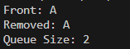

Task-3:
class Node:
"""Node of linked list"""

def __init__(self, data):
self.data = data
self.next = None
class LinkedList:
"""Singly linked list implementation"""
def __init__(self):
self.head = None
def insert(self, data):
"""Insert node at end."""
new_node = Node(data)
if self.head is None:
self.head = new_node
return
temp = self.head
while temp.next:
temp = temp.next
temp.next = new_node
def display(self):
"""Display linked list."""
temp = self.head
while temp:
print(temp.data, end=" -> ")
temp = temp.next
print("None")
# Example
ll = LinkedList()
ll.insert(5)
ll.insert(10)
ll.insert(15)
ll.display()

Output -
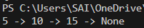

Task-4:
class HashTable:
"""
Hash table using chaining for collision handling
"""

def __init__(self, size=10):
self.size = size
self.table = [[] for _ in range(size)]
def hash_function(self, key):
return key % self.size
def insert(self, key):
index = self.hash_function(key)
self.table[index].append(key)
def search(self, key):
index = self.hash_function(key)
return key in self.table[index]
def delete(self, key):
index = self.hash_function(key)
if key in self.table[index]:
self.table[index].remove(key)
def display(self):
print(self.table)
# Example
h = HashTable()
h.insert(10)
h.insert(20)
h.insert(15)
print("Search 20:", h.search(20))
h.delete(20)
print("Search 20:", h.search(20))

Output-
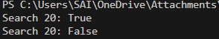

Task-5:
class Graph:
"""
Graph using adjacency list representation
"""

def __init__(self):
self.graph = {}
def add_vertex(self, vertex):
if vertex not in self.graph:
self.graph[vertex] = []
def add_edge(self, v1, v2):
self.graph[v1].append(v2)
self.graph[v2].append(v1)
def display(self):
for vertex in self.graph:
print(vertex, "->", self.graph[vertex])
# Example
g = Graph()
g.add_vertex("A")
g.add_vertex("B")
g.add_vertex("C")
g.add_edge("A", "B")
g.add_edge("A", "C")
g.display()

Output-
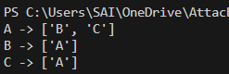

Task-6:
from collections import deque

class PatientQueue:
"""Queue for patient check-in"""
def __init__(self):
self.queue = deque()
def check_in(self, patient):
self.queue.append(patient)
def treat_patient(self):
if self.queue:
return self.queue.popleft()
return "No patients"
def display(self):
print(list(self.queue))
# Example
pq = PatientQueue()
pq.check_in("John")
pq.check_in("Mary")
pq.check_in("David")
pq.display()
print("Treated:", pq.treat_patient())
pq.display()

Output-
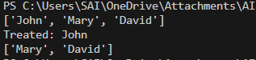

Task-7:
from collections import deque

traffic = deque()
traffic.append("Car1")
traffic.append("Car2")
traffic.append("Car3")
print("Vehicles waiting:", list(traffic))
print("Vehicle passed:", traffic.popleft())
print("Remaining:", list(traffic))
Output-
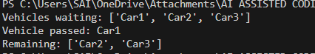

Task-8:
from collections import deque

orders = deque()
orders.append("Order101")
orders.append("Order102")
orders.append("Order103")
print("Orders in queue:", list(orders))
print("Processing:", orders.popleft())
print("Remaining Orders:", list(orders))

Output -
